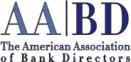

COMPLIMENTARY REGISTRATION

RISK-REWARD COMMITTEE

• Call (202) 463-4888
• Fax (202) 349-8080
• Email: dbaris@aabd.org
• Or mail this registration today

Return this registration to:

AMERICAN ASSOCIATION OF BANK DIRECTORS Suite 700, 1250 24th Street, NW
Washington, DC 20037

MEMBERSHIP SHOULD BE ENTERED FOR:

Name of Registrant:

Title: ______________________________________________________________________________________

Name of Institution: __________________________________________________________________________

Address:

City: State: Zip Code:

Phone Number:

Fax Number:

E-mail:

