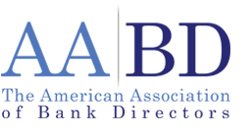

COMPLIMENTARY MEMBERSHIP REGISTRATION

RISK-REWARD COMMITTEE

Call: (202) 463-4888
Fax: (202) 349-8080
Email: dbaris@aabd.org
Or mail this registration form today

Return this registration to:

AMERICAN ASSOCIATION OF BANK DIRECTORS
1250 24th Street NW, Suite 700
Washington, DC 20037

MEMBERSHIP SHOULD BE ENTERED FOR:

Name of Member: ______________________________________________________________

Title: _________________________________________________________________________

Name of Institution: _____________________________________________________________

Address: ______________________________________________________________________

City: _____________________________ State: ______ Zip Code: _____________________

Phone Number: ________________________________________________________________

Fax Number: __________________________________________________________________

Email: ________________________________________________________________________

